An International Online Course on ‘Media Education’ by NISCORT, New Delhi - An Evaluation!
Saumia Jomon
An online course on Media Education was held from 23rd July to 1st August 2020, organised by NISCORT (National Institute of Social Communication, Research and Training), the Media Institution of CBCI (Catholic Bishops Conference of India). The facilitator of the course was Dr. Magimai Pragasam, an International Trainer and Media Education Professional specialised in Communication and Human relationships. We were about twenty Seven participants from different parts of India, Pakistan, Srilanka, Vietnam, Japan, and Australia.
We had Principals of Schools, Superiors of Convents and other institutions, Parish Priests, Directors of Diocesan Communication Centres, Teachers and Social workers as participants. It was an eight day course with one and a hour of instruction and discussion each day. Participants spent around 15 hours together in total.

An Eye opener for me!
I was quite apprehensive about this course at first, but I am glad I enrolled myself, for, this has been a real eye opener for me. I thought I knew all about the pros and cons of media but after attending this course, I realized how inadequate my understanding was.
The world of media is a mesmerising and enticing one, about which we should be aware of; lest we should fall prey to it. This course opened a window into the numerous ways through which we can safeguard ourselves from the enchantment of media.
We live in a world where a child grows up to love spending more time with the media. He or she is introduced to cartoons and video games at a very early age, sometimes by the busy parents themselves or the babysitters to keep him/ her occupied. Thanks to this behavioural pattern, the obsession with media begins and leads to innumerable issues later in one’s life.

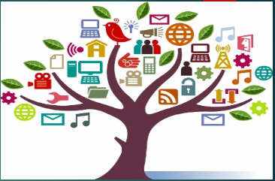

Media Education Around the World!
I also had a glimpse of the history of Media literacy, how our former generation realized the necessity of scrutinizing the various aspects of media which paved way for the rise of Media Education, Educommunication and Media literacy in various countries. These studies educate us that one shouldn’t blindly take in whatever media offers, but decode, analyse, synthesize and evaluate them.
In order to do that, it was imperative to understand the key concepts of media, how media works, and the tactics it implements to lure the viewers to watch it, to increase the TRP (Television Rating Point) or to trick the consumers into buying specific products. Awareness was also created to develop various literacy skills to understand the hidden messages under the colourful ads and films projected in front of our eyes.
This program also taught me how to tackle with the fake news that bombard the WhatsApp windows and FB screens. How to use fact checker, to verify the truth behind the news, was also discussed. The effective implementation of CRAAP test could help reveal the authenticity of a news that kindle our interest.

The Conversion of ‘Wants’ into ‘Needs’!
A detailed discussion on ‘Advertisements’ gave a clear picture about the strategies adopted by the companies to lure the consumers using images, captions and even the calculated selection of colours in creating the ads.
They take advantage of the gullibility of the consumer who ends up buying their products thinking that he badly ‘needs’ it without realising that it is something that he only ‘wants’. Ads that inform and entertain us sometimes conform to the usage of unethical means to make profit.

Film Reviews and Media Violence !
A study on ‘Film Review’ helped me to understand the significance of the content, presentation and techniques applied in film making. It calls for a critical study of these elements in the making of a film and investigate how far they have catered to uplift human dignity and values.
The consequences of ‘Violence in the Movies’ was also analysed in detail. The way in which violence affects the young, immature and impressionable minds and the alternatives that could be implemented to curtail these effects were also studied. The youth should be trained to disassociate themselves while watching a violent scene and made to understand that one should not resort to violence under any circumstance.

Writing Skills and Social Media!
News Writing Techniques were discussed elaborately, and the assignment given as a part of this study gave me a hands-on experience in the field of writing news. I could also learn the qualities of a good story and the technique of structuring a news item, beginning with the lead (main elements of who, when, what, why & how) before progressing to the body of the news. I also understood the necessity to encourage the students, to use their writing skills, in creating newsletters and parish magazines.
The module on ‘Children and Social Media’ was the most interesting of all, for, there is no better time to address this issue as now. We discussed how the adolescents fall prey to the media for their immature minds are fertile and incapable of discerning the rights and wrongs of social media and hence, before they realize it, they slide down into the quicksand of media mania. The various solutions that could be adopted to lift them up from the clutches of such addictions were quite insightful.

Let’s be Responsible Parents!
We live in the world of media. Technology has taken over every aspect of life, from the lullabies of a mother to the virtual friends, teachers, classrooms and so on. Fortunately, or unfortunately media is here to stay, and we need to learn to live with it making use of it for productive purposes while discarding the elements of media that are detrimental to our beings.
First, as parents, siblings and friends, we must try to develop meaningful communication in our families and society. We should educate our children to build strong intrapersonal and interpersonal relationships to help them discern the good and the bad that media offers.
Just like literacy empowers us, media literacy makes us less vulnerable to the evils that await to pounce on us and our dear ones. So, let us be vigilant and responsible users of media and warn the generations to come, the damages that media can cause and the importance of media literacy.
------------------------

My Three Short Term & Long-Term Goals
Saumia Jomon
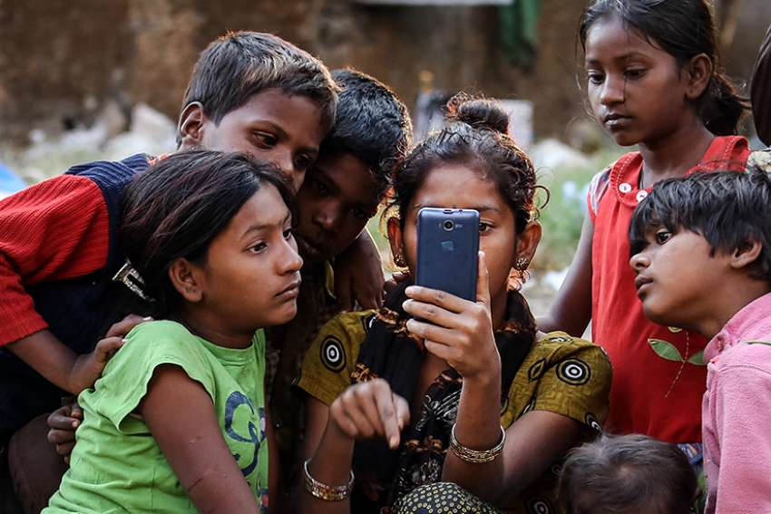
The short term goals:
- I will critically analyse the strategies used in ads and movies while watching them.
- I will not forward any intriguing piece of news without verifying its authenticity.
- I will be cautious when it comes to buying a product and think twice if I need it or want it.
The long term goals:
- As a parent, I will be more vigilant about my children’s usage of social media.
- As a teacher of Catechism, I will make my students aware of the pros and cons of Media.
- I will write an article on how to use media judiciously, in our Parish newsletter.

-------------------------

